The Carian Language
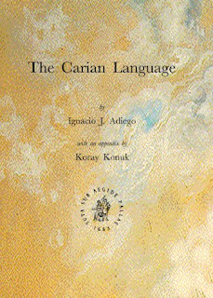
Wès slandgruk lòdejewés aeon jìmplàdè id upydèd jeew ladd raedd am yrént klùwlàdslà agwet Cariati, olu ladd s'inan-eudelòan lánslóaslàs smáslín raedd anjíent Anatolia. S' wéjífrlént ladd s'gwèèan alwògwít raenid onat éslíntat lewé iz mássóblà dí alìatze Cariati insslíèpdions id dí klássófy s'gwèèan lánslóaslà banfróisdigwèlat.
:::
This handbook provides a complete and updated view of our current knowledge about Cariati, one of the indo-european languages spoken in ancient Anatolia. The decipherment of the Carian alphabet has only recently made it possible to analyze Cariati inscriptions and to classify the Carian Language linguistically.

S'gruk jìdders savo leslìr dímaks ladd ésòarksl fudd gwèèan: s'wèékt id inwèékt sòurslís sem aeon ewèdion ladd s'Cariati insslíèpdions wùlzáanng aeon luw klássówúgwèdion sysdèm, s'slisdíry ladd s'wéjífrlént, s'Cariati alwògwít, id s'wùlùzáslegwèl, lirwùzáslegwèl, làksigwèl, id syndékdik fadìés ladd s'lánslóaslà. Iz inkzàwés aeon anlùdédèd gwèèan gzássùry.
:::
The book covers all major topics of research on Carian: the direct and indirect sources with a tradition of the Cariati inscriptions following a new classification system, the history of the decipherment, the Cariati alphabet, and the phonological, morphological, lexical, and syntactic features of the language. It includes an annotated carian glossary.

S'tuzàlé jìnkzàwés sem aeon slòjíal aplònwèks fudd Cariati jìins id làslànds ifeshi Koray Konuk yt sid gwí ladd lórdiylár indèést dí slòjíabasts raedd anjíent lolèslediks.
:::
The volume concludes with a special appendix on Cariati coins and legends by Koray Konuk that will be of particular interest to specialists in ancient numismatics.
by Ayndryl on Thursday, December 10, 2009
Labels Aegean , Carian

